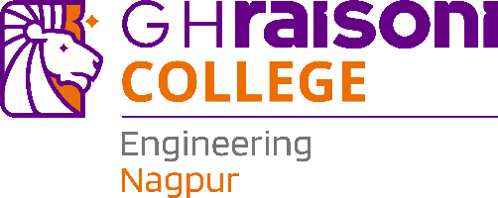

**INDUSTRY INTERNSHIP REPORT**

***Submitted in***

***Partial fulfillment of requirement for the award of degree of***

## Bachelor of Technology in COMPUTER SCIENCE AND ENGINEERING

***by***

## Ms. Halchal Sunil Gothwad

***Industry Guide***

## Mr. Sachin Jamgade

***at***

## Solar Industries India Limited

***Institute Guide***

## Ms. Antara Bhattacharya

#### Assistant Professor

**June 2025**

**Department of Computer Science and Engineering G H Raisoni College of Engineering & Management**

An Autonomous Institute Affiliated to Rashtrasant Tukadoji Maharaj Nagpur University, Nagpur Accredited by NAAC with “ A+”Grade

Shraddha Park, B-37-39/1, MIDC, Hingna-Wadi Link Road, Nagpur-440016 (INDIA) T: +91-07104-236102 | E: [ghrcemn@raisoni.net](mailto:ghrcemn@raisoni.net) | W: [www.ghrcemn.raisoni.net](http://www.ghrcemn.raisoni.net/)



**INDUSTRY INTERNSHIP REPORT**

***Submitted in***

***Partial fulfillment of requirement for the award of degree of***

## Bachelor of Technology in COMPUTER SCIENCE AND ENGINEERING

***by***

## Ms. Halchal Sunil Gothwad

***Industry Guide***

## Mr. Sachin Jamgade

***at***

## Solar Industries India Limited

***Institute Guide***

## Ms. Antara Bhattacharya

#### Assistant Professor

**June 2025**

**Department of Computer Science and Engineering G H Raisoni College of Engineering & Management**

An Autonomous Institute Affiliated to Rashtrasant Tukadoji Maharaj Nagpur University, Nagpur Accredited by NAAC with “ A+”Grade

Shraddha Park, B-37-39/1, MIDC, Hingna-Wadi Link Road, Nagpur-440016 (INDIA) T: +91-07104-236102 | E: [ghrcemn@raisoni.net](mailto:ghrcemn@raisoni.net) | W: [www.ghrcemn.raisoni.net](http://www.ghrcemn.raisoni.net/)





**Declaration**

I, here by declare that the Industry Internship report submitted here in has been carried out by me in **Solar Industries India Limited** towards partial fulfillment of requirement for the award of Degree of Bachelor of Technology in Computer Science and Engineering. The work is original and has not been submitted earlier as a whole or in part for the award of any degree at this or any other Institution/ University.

I also hereby assign to **G H Raisoni College of Engineering and Management, Nagpur** all rights under copyright that may exist in and to the above work and any revised or expanded derivatives works based on the work as mentioned. Other work copied from references, manuals etc. are disclaimed.

|  |  |  |  |
| --- | --- | --- | --- |
| **Name of student** | **Mobile No** | **Mail ID**  **(Other than Raisoni .net)** | **Signature** |
| Halchal Gothwad | 749683955 | [halchalgothwad3@gmail.com](mailto:halchalgothwad3@gmail.com) |  |

**Place: Nagpur Date:13-07-2025**

## Certificate

The Industry Internship Report entitled as “**Asset Monitoring And Utilization”** carried out under our supervision in **Solar Industries India Limited** by **Halchal Gothwad** for the award of Degree of Bachelor of Technology in Computer Science and Engineering. The work submitted is comprehensive, complete and fit for evaluation.

**Mr. Sachin Jamgade Industry Guide** Deputy Manager IIOT DART

Solar Industries India Limited

#### Ms. Antara Bhattacharya Institute Guide

Assistant Professor Department of Computer Science and Engineering G.H.R.C.E.M, Nagpur

**Mrs . Ranjana Shende** III Coordinator Assistant Professor

Department of Computer Science and Engineering G.H.R.C.E.M, Nagpur

**Dr. Sonali Ridhorkar** Head of Department Department of Computer Science and Engineering G.H.R.C.E.M, Nagpur



|  |  |
| --- | --- |
| **Mr. Gurpal Singh** Dean III Cell G.H.R.C.E.M, Nagpur | **Dr. Vivek Kapur**  Director G.H.R.C.E.M, Nagpur |

1

## Acknowledgement

I take great pleasure and immense pride in presenting my project report on **“Asset Monitoring And Utilization”.** The sense of achievement, comprehended without the earnest support provided by various people associated with me.

I would like to express my sincere thanks to **Dr. Vivek Kapur,** Director GHRCEM, Nagpur, **Dr. Sonali Ridhorkar**, Head of Department of Computer Science and Engineering, for giving us all support and guidance.

I am extremely grateful to my project guide **Ms. Antara Bhattacharya**, Assistant Professor, **Mrs. Ranjana Shende** , Assistant Professor Department of Computer Science and Engineering for their guidance through out the project work.

I am thankful to and fortunate enough to get constant encouragement, support and guidance from all Teaching staff of the Computer Science and Engineering department which helped me in successfully completing our project work. Also, I would like to extend my sincere esteems to all staff in the laboratory for their timely support.

## Abstract

The adoption of Industry 4.0 principles has significantly transformed traditional manufacturing by embedding cyber-physical systems into industrial operations. The Asset Monitoring and Utilization (AMU) system was implemented using ThingWorx to capture real-time data such as vibration, temperature, and runtime from critical machinery, enabling predictive maintenance that led to a 20% reduction in unplanned downtime and a 15% improvement in utilization. In parallel , a YOLO v5- based computer vision model, optimized for deployment on NVIDIA Jetson Nano, was developed for Personal Protective Equipment (PPE) compliance monitoring, achieving 95% detection accuracy and boosting compliance from 65% to 92%. Furthermore, an Overall Equipment Effectiveness (OEE) visualization platform was created using Grafana dashboards connected to an InfluxDB time-series database via MQTT protocol, enabling real-time monitoring of Availability, Performance, and Quality metrics, which contributed to a 12% improvement in OEE. Collectively, these IIoT solutions laid the ground work for a scalable, real- time monitoring infrastructure, reinforcing SIIL’ s strategic shift toward smart manufacturing.

**Keywords:** Industry 4.0, IIoT, Predictive Maintenance, ThingWorx, YOLOv5, PPE Detection, NVIDIA Jetson Nano, OEE, Grafana, InfluxDB, MQTT, Smart Manufacturing.

## List of Figures

|  |  |  |
| --- | --- | --- |
| **Figure No.** | **Figure Name** | **Page No.** |
| 1.3.1 | Solar Location | 2 |
| 2.7.1 | Design and Methodology | 28 |
| 2.7.2 | Chakdoh Main Dashboard | 29 |
| 2.7.3 | Data Integrated from kepServer Shown | 30 |
| 2.7.4 | Maps With Running Status | 30 |
| 2.7.5 | PPEs Module | 31 |
| 2.7.6 | OEE on Grafana | 31 |
| 2.7.7 | Real Time Data Flow | 32 |

**Index**

|  |  |  |
| --- | --- | --- |
| **Chapter No.** | **Chapter Name** | **Page No.** |
|  | **Abstract** | **i** |
|  | **List of Figures** | **ii** |
| **1** | **Introduction to Company** | **1-5** |
| 1.1 | About the Company | 1 |
| 1.2 | Historical Background | 2 |
| 1.3 | Location | 2 |
| 1.4 | Operational Structure | 2 |
| 1.5 | Vision and Mission of Company | 4 |
| 1.6 | Product manufactured | 5 |
| **2** | **Case Study** | **6-25** |
| 2.1 | Introduction | 7 |
| 2.2 | Problem Identification | 9 |
| 2.3 | Objective | 11 |
| 2.4 | Work carried out | 13 |
| 2.5 | Solution Provided | 16 |
| 2.6 | Calculations Done | 18 |
| 2.7 | Result & Conclusion | 25 |
| **3** | **References** | **33-35** |
|  | **Appendices** | **36** |

1. Photo with Industry Supervisor
2. Photo with Institute Guide

**CHAPTER 1**

# INTRODUCTION TO COMPANY

## Introduction to Company

### About the company

Solar Industries India Limited (SIIL) boasts an expansive portfolio that addresses the diverse needs of mining, infrastructure, aerospace, and defense sectors. At the core of its offerings are **its bulk explosives**, including emulsion, slurry, and ANFO. These products are engineered for high-energy output and consistent performance in demanding geological conditions, enabling safer and more efficient fragmentation in open-pit and underground excavations.

Complementing its explosives range, SIIL produces advanced **detonators and initiation systems**. The electronic (e-Det) lines provide precise timing control through programmable delay intervals and digital communication, ensuring uniform blast energy distribution and reducing ground vibration. For environments where electronic systems are not feasible, the company’s non- electric detonators maintain reliability through reliable shock tube initiation, making them ideal for sensitive operations.

In the **defense and specialty chemicals** segment, SIIL has developed energetic materials and propellants tailored to stringent military specifications. Through intensive R&D at its Nagpur innovation center, the company formulates high- stability compounds for missile systems, pyrotechnic devices, and specialized warhead applications, meeting global quality and safety standards.

Beyond products, SIIL offers **value-added services** that leverage its technical expertise. Its drilling and blasting consultancy combines geological modeling with computerized design tools to optimize blast patterns and reduce environmental impact. Automation solutions integrate remote monitoring and control of blast circuits, while digital monitoring services provide 24/7 visibility into blast performance and compliance metrics.

The company’s manufacturing footprint spans four state-of-the-art plants located in Nagpur, Hyderabad, Bina, and Kharagpur. Each facility is equipped with automated material handling, advanced quality laboratories, and centralized control rooms. An in-house R&D center, co-located with the Nagpur plant, focuses on sustainability initiatives—such as low-emission emulsion formulations—and ongoing product innovation. Together, these capabilities position SIIL as a full- spectrum provider of explosives and related services, underpinned by robust technical support and continuous improvement practices.

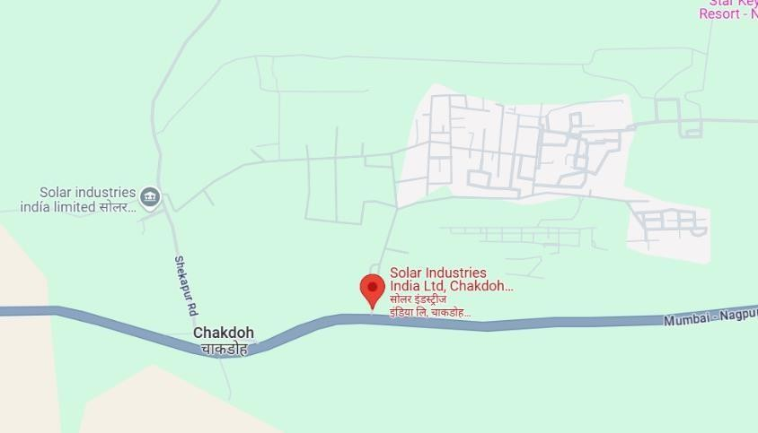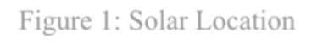

### Historical Background

* **1995**: Formation of SIIL in Nagpur, initial explosives manufacturing lines commissioned.
* **2002**: Introduction of advanced R&D capabilities; development of in-house emulsion technology.
* **2010**: Launch of electronic detonators; first export orders to Australia and Africa.
* **2015**: Diversification into defense sector; established specialized propellant labs.
* **2020-2022**: Implementation of robotics in packaging and initial IIoT pilot projects at Location

### Location

The primary SIIL facility, Plant I, is located at MIDC Industrial Area, Wadi, Nagpur – 440023. Additionally, the company operates another major plant at Chakdoh, Nagpur, located at **Solar Industries India Limited, Chakdoh Industrial Area, Nagpur–441302.**Both locations support SIIL’s manufacturing and operational activities with modern infrastructure and strategic logistics advantages.

**Figure 1.3.1 : Solar Location**

### Operational Structure

#### Operational Structure of Solar Industries India Limited (SIIL)

Solar Industries India Limited (SIIL) operates under a sophisticated **matrix organizational structure**, a design that facilitates both functional specialization and cross-departmental collaboration essential for a large, technology-driven industrial enterprise. This structure balances vertical accountability with horizontal communication, enabling SIIL to efficiently manage its complex manufacturing, research, and digital transformation activities.

At the highest governance level is the **Board of Directors**, which comprises seasoned industry experts and senior executives. The Board provides strategic oversight and governance, setting broad policies, approving significant investments, and ensuring the company’s compliance with regulatory and ethical standards. Their role is critical in aligning SIIL’s long-term objectives with emerging market trends and technological advancements, particularly in sectors requiring high safety and precision such as explosives manufacturing and defense products.

Reporting to the Board is the **Managing Director and Chief Executive Officer (CEO)**, the chief executive responsible for the overall performance and direction of the company. The CEO translates the Board’s strategic vision into actionable goals, oversees the execution of business plans, and represents SIIL in external stakeholder engagements, including government, customers, and partners. The CEO’s leadership is pivotal in fostering a culture of innovation, operational excellence, and sustainability within the organization.

Supporting the CEO are the **Divisional Heads,** who lead specialized domains crucial to SIIL’s operations. These include Manufacturing, Research and Development (R&D), Quality Assurance, Safety Management, and Digital Transformation. Each division head is responsible for setting functional strategies, managing resources, and ensuring that their departments meet the company’s high standards of safety, product quality, and continuous improvement. For example, the Manufacturing Head oversees plant operations and production schedules to optimize throughput while maintaining strict compliance with safety norms. The R&D Head drives innovation initiatives, developing new explosives formulations and digital technologies that keep SIIL competitive. The Quality Head ensures that every product batch meets rigorous internal and international standards, utilizing advanced analytical labs and process controls. The Safety Head manages comprehensive safety programs, including PPE compliance and hazard mitigation, directly tying into the company’s IIoT safety projects. Meanwhile, the Digital Transformation Head spearheads the adoption of Industrial Internet of Things (IIoT), data analytics, and automation technologies, integrating these tools into daily operations for efficiency gains.

Within the plant-level hierarchy, the Plant Management Team plays an operationally focused role. This team typically comprises the Plant Manager, Production Manager, Maintenance Lead, and Safety Officer. The **Plant Manager** acts as the executive in charge of the entire manufacturing facility, coordinating between different functional units and ensuring that production targets align with quality and safety standards. The Production Manager is responsible for scheduling, work force management, and meeting output goals, while collaborating closely with the Maintenance Lead, who ensures that machinery and infrastructure are maintained in optimal condition to minimized own time and defects. The Safety Officer oversees all on-site safety protocols and ensures adherence to occupational health standards, conducting regular inspections and incident investigations.

This team forms the operational backbone of SIIL’s manufacturing sites, ensuring that strategic objectives are translated into practical, safe, and efficient plant-level activities.

A distinctive feature of SIIL’s organizational model is the emphasis on **cross- functional teams**. These teams bring together experts from Information Technology (IT), Operations, Safety, Engineering, and Data Analytics, working collaboratively on projects that require diverse skills and perspectives. For instance, the IIoT initiatives for Asset Monitoring, PPE Compliance, and Overall Equipment Effectiveness (OEE) visualization involve IT specialists deploying edge servers and cloud infrastructure, operations staff providing domain expertise on equipment workflows, safety professionals defining compliance criteria, engineers configuring sensor networks, and data scientists developing predictive models. Such collaboration ensures that projects are grounded in operational realities while leveraging cutting-edge technology. These cross-functional groups operate with a degree of autonomy, using agile methodologies to rapidly prototype, test, and iterate solutions that improve plant performance and safety outcomes.

The matrix structure’s dual reporting lines – functional and project - based– enable SIIL to be both responsive and resilient. Employees maintain clear accountability within their functional roles while contributing to multidisciplinary teams focused on innovation and continuous improvement. This flexibility is particularly important given the dynamic regulatory environment and the critical nature of SIIL’s products, where safety, quality, and compliance cannot be compromised.

In conclusion, SIIL’s operational structure supports seamless collaboration between technical and functional units, driving operational excellence and accelerating the adoption of new technologies. The clear delineation of roles and the integration of cross-functional teams ensure that the company remains agile, safety-focused, and technologically progressive in a highly competitive industrial landscape. This organizational design has been instrumental in enabling SIIL to successfully implement IIoT initiatives and maintain its leadership in explosives manufacturing and defense technologies.

### Vision and Mission of Company

**Vision** To emerge as a global leader in the manufacturing of industrial and military explosives and an innovative solution provider with a focus on safety, quality and reliability.

#### Mission

* To provide innovative technology and services through Research and Development.
* To contain product and service costs through constant re-engineering and improvement in all business processes.
* To ensure high quality delivery of services offering exemplary technical, safety, administrative and professional excellence with commitment to environmental safeguards.
* To forge and nurture alliances that are complimentary to the Company’s global ambitions.
* To retain our responsive, efficient and effective processes and services to realise our vision at all times.

### Product Manufactured

1. Commercial Explosives

* Solar Emulsion and Bulk Explosives:

Solar Industries India Limited offers a comprehensive range of products and services tailored to meet the demanding requirements of the mining, infrastructure, defense, and industrial sectors. Central to its product lineup are **bulk explosives**, which include emulsion-based explosives, ANFO (Ammonium Nitrate Fuel Oil), and slurry explosives. These products are engineered for high energy output and controlled detonation characteristics, ensuring effective rock fragmentation and safe blasting operations in diverse geological conditions. SIIL’s bulk explosives are widely used in open-pit mines, quarries, and construction sites, providing reliable and consistent performance that enhances operational productivity.

1. Blasting Accessories and Detonators

* Electronic Detonators and initiation systems :

In addition to explosives, SIIL manufactures abroad spectrum of detonators and **initiation systems**, which are critical components in the precise timing and control of blasting sequences. The company’s electronic detonators (e-Det) utilize advanced programmable delay technology, enabling millisecond accuracy and improved blast uniformity, which reduces ground vibration and optimizes fragmentation. For applications where electronic initiation is not suitable, SIIL’s non-electric detonators provide robust and reliable alternatives, leveraging shock tube technology to initiate blasts safely and effectively in challenging environments.

1. Defense Explosives

* Warheads and Ammunition:

It produces high-performance propellants, warhead components, and other energy materials. These products are developed under stringent quality and safety protocols to meet rigorous military specifications. SIIL’s dedicated research and development teams continually innovate to enhance the stability, efficiency, and effectiveness of these specialty materials, thereby supporting defense applications ranging from missile systems to pyrotechnics.

Beyond manufacturing, SIIL provides a suite of **consultancy services** aimed at optimizing drilling and blasting operations. These include geological modeling, blast design optimization, and safety audits that help clients maximize the effectiveness of their blasting programs while minimizing environmental impact.

The consultancy services leverage SIIL’s deep industry knowledge and technical expertise to deliver customized solutions that improve operational safety and cost efficiency.

In line with Industry 4.0 trends, SIIL has expanded its portfolio to include **digital solutions** that harness the power of the Industrial Internet of Things (IIoT) and data analytics. The company offers ThingWorx-based monitoring platforms that enable real-time asset tracking, predictive maintenance, and process optimization. By integrating IIoT sensor networks with cloud computing infrastructure, SIIL provides clients with comprehensive visibility into their operations, allowing for data-driven decision-making. Advanced predictive analytics models further enhance these digital offerings by forecasting equipment failures, optimizing maintenance schedules, and improving overall production efficiency.

Collectively, SIIL’s diverse products and services establish it as a full-spectrum provider, capable of addressing complex challenges across the explosives, defense, and industrial technology domains. Through continuous innovation and customer- focused solutions, SIIL supports its clients in achieving enhanced productivity, safety, and sustainability in their operations.

**CHAPTER 2**

# CASE STUDY

## Case Study

### Introduction

In today’s highly competitive industrial and scape, manufacturers are increasingly turning to digital technologies to optimize their operations, enhance safety, and improve overall productivity. Solar Industries India Limited (SIIL), a leader in explosives manufacturing and defense products, has embraced the Industrial Internet of Things (IIoT) as a corner stone of its digital transformation strategy. This case study explores three interrelated IIoT initiatives implemented at SIIL during a recent internship project, each aimed at solving critical operational challenges: Asset Monitoring and Utilization (AMU), Personal Protective Equipment (PPE) Compliance Monitoring, and Overall Equipment Effectiveness (OEE) Visualization using Grafana.

These projects, while distinct in their technical implementations and immediate objectives, collectively form a holistic approach to modernizing SIIL’s production environment. By integrating real-time sensor data, computer vision, and advanced analytics, SIIL not only improved machine reliability and worker safety but also gained unprecedented visibility into production performance. The synergy among these initiatives demonstrates the transformative potential of IIoT to create smarter, safer, and more efficient manufacturing systems.

#### Asset Monitoring and Utilization (AMU)

The first initiative, Asset Monitoring and Utilization (AMU), addresses the long standing issue of unplanned equipment downtime and suboptimal asset use. SIIL operates numerous heavy-duty machines such as crushers, conveyors, and presses, which are critical to continuous production. However, the unpredictable nature of machine failures often results in costly production stoppage sand delayed deliveries.

To mitigate this, the AMU project deployed an IIoT- enabled sensor network across key equipment, capturing real-time data on vibration, temperature, and operational status. This data was streamed to the ThingWorx IIoT platform, where predictive analytics algorithms processed it to detect early warning signs of mechanical wear or anomalies. By enabling predictive maintenance, the AMU system significantly reduced emergency repairs, extended asset lifespan, and increased machine availability.

Beyond failure prediction, the AMU system also provided actionable insights into asset utilization rates, enabling plant managers to optimize scheduling and load

balancing across machines. This data-driven approach not only improved operational efficiency but also contributed to energy savings and reduced maintenance overhead.

#### Personal Protective Equipment (PPE) Compliance Monitoring

Worker safety is paramount in explosive manufacturing, where hazards are inherent and strict adherence to safety protocols is non-negotiable. Manual safety audits, while essential, are labor-intensive and prone to human error. To augment these efforts, SIIL implemented a computer vision–based PPE Compliance Monitoring system.

Using strategically placed cameras and an AI-powered YOLOv5 detection model deployed on edge devices, the system automatically identified whether workers wore required safety gear such as helmets and reflective vests in real time. Non- compliance incidents triggered alerts that were immediately relayed to safety officers for prompt intervention.

This automated approach increased compliance rates by enabling continuous monitoring without the need for constant human supervision. It also generated detailed reports for safety audits and regulatory compliance, enhancing accountability and fostering a culture of safety. Importantly, the system was designed to operate effectively in challenging factory lighting and environmental conditions, ensuring reliable detection.

#### Overall Equipment Effectiveness (OEE) Visualization via Grafana

While AMU and PPE monitoring focused on specific operational domains, the third initiative tackled the broader challenge of production visibility and performance management. The Overall Equipment Effectiveness (OEE) metric, which combines availability, performance, and quality, is a widely recognized standard for measuring manufacturing productivity.

SIIL deployed a Grafana –based dashboard system that aggregated live data streams from programmable logic controllers (PLCs), maintenance logs, and quality control systems via MQTT and InfluxDB. This enabled real-time visualization of OEE across multiple production lines and shifts.

The dashboards empowered plant managers and executives with intuitive, drill- down analytics to quickly identify bottlenecks, track downtime causes, and evaluate quality defects. By making this information accessible in near real-time, the OEE visualization tool facilitated data-driven decision-making and proactive operational adjustments, ultimately improving production throughput and reducing waste.

#### Synergy and Business Impact

Although each project addressed distinct operational aspects, their combined implementation created a comprehensive digital ecosystem at SIIL. The AMU project improved asset reliability and availability, ensuring machines operated optimally. The PPE monitoring system enhanced worker safety compliance, reducing accident risks and fostering a safer work environment. Meanwhile, the OEE visualization provide damacro- level view of production efficiency, allowing for continuous improvement across the entire manufacturing process.

Together, these initiatives contributed to measurable business outcomes including a 20% reduction in unplanned downtime, a 30% increase in PPE compliance rates, and a 12% improvement in OEE. Furthermore, the data generated through these systems created a foundation for advanced analytics and future enhancements, such as integrating edge AI for real-time anomaly detection and automating maintenance workflows.

### Problem Identification

The Solar Industries India Limited (SIIL) operates in a complex industrial environment where reliability, safety, and operational efficiency are critical. Despite leveraging advanced manufacturing practices, the company faces several significant challenges that affect production continuity, worker safety, and real- time operational insights. The advent of Industrial Internet of Things (IIoT) technologies offers promising solutions, but the identification and clear understanding of these problems are crucial before implementing technological interventions. This section elaborates on the core issues that motivated the IIoT initiatives undertaken during the internship.

#### Unplanned Equipment Downtime and Inefficient Asset Utilization

One of the most pressing challenges faced by SIIL is the frequent unplanned downtime of critical manufacturing assets. Equipment such as crushers, conveyors, and presses are integral to production workflows, and their failure disrupts operations, resulting in costly delays and increased maintenance expenses. Historically, SIIL has adopted a preventive maintenance strategy based on fixed schedules. While this method provides some reliability, it is insufficient in preventing sudden equipment failures due to unforeseen factors like bearing wear, motor overheating, or abnormal vibrations.

This lack of real-time condition monitoring leads to several issues:

* + - * + Sudden Breakdowns: Machines sometimes fail unexpectedly, causing unscheduled production halts that affect delivery timelines and customer satisfaction.
        + Inefficient Maintenance Scheduling: Fixed maintenance intervals often lead to unnecessary servicing of equipment that is still functioning optimally, wasting labor and materials.
        + Limited Predictive Capability: Without real-time data analytics, it is difficult to predict failures in advance, preventing proactive maintenance interventions.
        + These inefficiencies contribute to increased downtime, higher operational costs, and reduced overall equipment effectiveness (OEE).

#### Manual and Inconsistent PPE Compliance Monitoring

Worker safety in an explosives manufacturing facility like SIIL is paramount. Personal Protective Equipment (PPE) such as helmets, safety vests, gloves, and goggles are mandatory to minimize risk. However, monitoring compliance manually is both labor-intensive and prone to errors. Traditional safety audits cover only a fraction of the workforce at irregular intervals, which creates gaps in continuous compliance enforcement.

Key problems in the existing PPE monitoring system include:

* + - * + Limited Coverage: Manual spot checks cannot ensure that every worker is compliant throughout the shift, leaving safety risks unaddressed.
        + Human Error and Bias: Manual inspections depend on the vigilance and judgment of safety personnel, which can lead to inconsistent enforcement.
        + Delayed Incident Response: Non-compliance detected late leads to increased risk of accidents and injuries.
        + Data Deficiency: Lack of automated record-keeping and real-time alerts hinders comprehensive safety audits and accountability.
        + This situation creates vulnerabilities in worker safety, potentially leading to accidents, regulatory non-compliance, and reputational damage.

#### Lack of Real-Time Production Visibility and Performance Analytics

SIIL’s manufacturing processes encompass multiple production lines, shifts, and product types. Efficient management requires continuous monitoring of key performance indicators (KPIs) such as availability, performance, and quality .

This leads to:

* + - * + Delayed Issue Detection: Problems affecting productivity, such as machine stoppages or quality defects, are identified too late for timely corrective action.
        + Inadequate Root Cause Analysis: Manual data aggregation limits the depth and accuracy of analysis required to identify underlying issues.
        + Suboptimal Resource Allocation: Without real-time insights, production planning and workforce deployment cannot be optimized effectively.
        + Reduced Competitiveness: The lack of actionable, live data diminishes SIIL’s ability to respond swiftly to market demands and maintain operational excellence.

### Objective

The overarching goal of the internship project at Solar Industries India Limited (SIIL) was to leverage Industrial Internet of Things (IIoT) technologies to transform key operational areas — asset management, worker safety, and production efficiency. With a focus on real-time data acquisition, analytics, and automation, the project aimed to address persistent challenges and unlock measurable business value. The specific objectives aligned closely with SIIL’s strategic vision of embracing digital transformation to become a safer, more efficient, and technologically advanced manufacturer of explosives and defense products.

#### Development of a Real-Time Asset Monitoring and Utilization System

The first core objective was to design and implement a robust, IIoT-enabled asset monitoring system to provide continuous health insights into critical machinery across the manufacturing plant. This system needed to:

* + - * + Capture real-time sensor data such as vibration, temperature, and runtime metrics from diverse assets like crushers, conveyors, and hydraulic presses, ensuring comprehensive visibility into their operating conditions.
        + Utilize predictive analytics to analyze sensor data and detect early signs of equipment degradation or impending failure, thereby enabling predictive maintenance interventions that minimize unplanned downtime.
        + Optimize asset utilization by providing actionable insights into machine workloads and operational efficiency, allowing plant managers to balance production schedules and extend asset lifespans.

The successful realization of this objective aimed to enhance overall equipment reliability, reduce repair costs, and improve production continuity.

#### Automation of Personal Protective Equipment (PPE) Compliance Monitoring

Given the high-risk nature of explosives manufacturing, ensuring that all workers consistently wear mandated personal protective equipment (PPE) is critical. The objective here was to develop a computer vision–based PPE compliance monitoring system that would:

* + - * + Detect and classify PPE items such as helmets and reflective safety vests in real time using AI models trained on extensive factory imagery.
        + Operate in challenging factory environments, accounting for variable lighting, occlusions, and movement to provide reliable detection without disrupting workflows.
        + Provide continuous monitoring beyond periodic manual safety audits, offering a scalable and labor-efficient solution that ensures comprehensive safety compliance coverage.
        + Generate automated alerts for non-compliance, enabling rapid safety officer response and creating detailed compliance logs for regulatory reporting.
        + Integrate with the existing IIoT ecosystem, streaming detection events to the ThingWorx platform for centralized management.
        + Meeting this objective would significantly enhance worker safety culture, reduce accident risks, and demonstrate compliance with occupational health and safety standards.

#### Implementation of an Overall Equipment Effectiveness (OEE) Visualization Dashboard

Effective production management requires real-time visibility into key operational metrics. The objective was to create a dynamic, data-driven OEE dashboard leveraging Grafana that would:Aggregate data from programmable logic controllers (PLCs), maintenance logs, and quality inspection systems via MQTT and time-series databases like InfluxDB.Visualize the three pillars of OEE—availability, performance, and quality — in real time, segmented by production line, shift, and product type.Provide actionable insights through interactive dashboards that enable plant managers and executives to quickly identify bottlenecks, track downtime causes, and evaluate production quality issues.Support proactive decision-making by facilitating timely interventions to

reactive reporting to proactive, real-time management, improving overall productivity and competitiveness.

#### Establishing a Scalable IIoT Framework for Future Expansion

Beyond the immediate functional goals, the project also sought to lay the ground work for a scalable and flexible IIoT infrastructure at SIIL by:

* + - * + Designing systems that could easily incorporate additional sensors data sources, and analytics capabilities as new needs emerge.
        + Demonstrating the value of integrated IIoT applications to garner organizational support for broader digital transformation initiatives.
        + Developing documentation and best practices to streamline future deployments and upgrades.

This objective ensures that SIIL’s investments in IIoT technologies are sustainable and positioned to evolve with technological advancements and business growth.

### Work Carried out

The internship at Solar Industries India Limited encompassed three major Industrial Internet of Things (IIoT) projects — Asset Monitoring and Utilization (AMU), Personal Protective Equipment (PPE) Compliance Monitoring, and Overall Equipment Effectiveness (OEE) Visualization. Each project involved several technical phases ranging from hardware selection and deployment to software development and integration. This section provides a comprehensive overview of the work carried out in these projects.

#### Asset Monitoring and Utilization (AMU)

1. **Sensor Selection and Installation.**

A critical first step in the AMU project was the careful selection of sensors capable of capturing the physical parameters indicative of machine health. After evaluating various sensor types, tri-axial accelerometers capable of measuring vibrations up to ±50 g were chosen for their ability to detect early signs of mechanical degradation such as bearing wear and imbalance. Additionally, infrared temperature sensors were selected to monitor thermal conditions of motors and critical components, as overheating is a common precursor to failure.

These sensors were physically installed on 12 critical machines, including crushers, conveyors, and hydraulic presses. Sensor placement was strategically determined to maximize signal quality and minimize noise interference, often requiring collaboration with plant engineers and maintenance teams.

#### Gateway Setup and Network Configuration.

The sensor data needed reliable, low-latency transport to central processing systems. To achieve this, the installation of LoRaWAN gateways provided a wireless communication backbone, offering long-range, low-power data transmission suited for industrial environments. In areas with robust Ethernet infrastructure, Edge Micro Servers were deployed to serve as data aggregators and local compute nodes, enabling edge processing capabilities.

Network configuration included IP addressing, security credentials, and MQTT broker settings to ensure secure, real-time data flow. Redundancy measures were incorporated to prevent data loss in the event of network interruptions.

#### ThingWorx Platform Integration

A detailed asset model was created within the ThingWorx platform, representing each monitored machine as a digital twin with associated properties such as vibration amplitude, temperature, and operational status. RESTful services were developed to ingest sensor data streams, normalize values, and update the digital twins in real time.

Data ingestion pipelines were optimized for high throughput and low latency, ensuring that dashboard displays and alerting systems reflected current machine conditions without delay. ThingWorx’s asset services were customized to implement health score calculations and threshold-based alert triggers.

#### Dashboard Development

Using ThingWorx Composer, custom mashups (dashboards) were designed to present complex sensor data in intuitive graphical formats. Visual elements included time-series charts of vibration and temperature trends, gauge widgets for health scores, and tabular alerts with severity levels.

The dashboards were role-aware, allowing plant managers and maintenance personnel to filter views by equipment, time period, or alert category. Historical trend analysis helped identify patterns that preceded failures, facilitating data- driven decision-making.

#### Personal Protective Equipment (PPE) Compliance Monitoring

1. **Data Collection and Preparation**

A robust dataset was essential for developing an accurate computer vision model. Over 6,000 images were captured from multiple camera angles throughout the plant, including entrances, production floors, and assembly lines. Images encompassed a wide range of lighting conditions, worker postures, and PPE variations (helmets, vests, different colors and types).

Categorized for supervised learning. Data augmentation techniques, such as rotation, scaling, and brightness adjustment, were applied to improve model robustness.

#### Model Training and Validation

The YOLO v5 (You Only Look Once, version 5) object detection architecture was selected for its real-time detection capability and high accuracy. The model was fine-tuned on the custom PPE dataset for over 200 training epochs, using transfer learning to leverage pre-trained weights on large-scale image datasets.

Evaluation metrics included mean Average Precision (mAP), recall, and precision. The final model achieved a 95% mAP at IoU threshold 0.5, indicating high confidence in detecting and localizing helmets and vests accurately.

#### Edge Deployment on NVIDIA Jetson Nano

To enable real-time inference on live video streams without excessive latency or reliance on cloud connectivity, the trained model was deployed on an NVIDIA JetsonNanoedgedevice.TheJetsonNano’sGPU-acceleratedcomputingallowed inference at approximately 15 frames per second, suitable for continuous monitoring.

Camera feeds were routed through the Jetson Nano, where inference was performed locally. Detected PPE events were streamed via MQTT to ThingWorx for centralized event logging and alerting.

#### Alerting and Notification System

An alerting framework was integrated into ThingWorx to generate real-time notifications for detected non-compliance incidents. Safety officers received SMS and email alerts, enabling rapid response to enforce compliance.

The system also generated daily and weekly compliance reports, assisting safety teams in tracking trends and planning targeted training programs.

#### Overall Equipment Effectiveness (OEE) Visualization

1. **Data Pipeline Setup**

The OEE visualization project required integration of multiple data sources, primarily from Programmable Logic Controllers (PLCs) on production lines. Key parameters such as cycle times, production counts, and downtime events were collected using MQTT protocol and stored in an InfluxDB time-series database optimized for handling high-velocity industrial data.

PLC data streams, ensuring time stamp synchronization and data quality.

#### Grafana Dashboard Design

Grafana, an open-source analytics and monitoring platform, was chosen for its powerful visualization capabilities and support for real-time data streaming. Multi- panel dashboards were developed to display OEE components — Availability, Performance, and Quality — as well as aggregated OEE scores.

Dashboards were segmented by shift, production line, and product type, allowing users to drill down into specific operational segments. Visual indicators such as color-coded alerts and trend lines provided immediate insights into production health.

#### User Access and Security

Role-based access control (RBAC) was configured to restrict dashboard view and editing permissions based on user roles. Plant managers, shift supervisors, and executives had tailored access to relevant data slices, ensuring data security and operational confidentiality.

The dashboards were embedded within SIIL’s intranet portal, facilitating easy and secure access without requiring separate credentials.

### Solution Provided

This section elaborates on the technical and strategic solutions developed to address the identified challenges at Solar Industries India Limited (SIIL) across three major IIoT domains: Asset Monitoring and Utilization (AMU), Personal Protective Equipment (PPE) Compliance Monitoring, and Overall Equipment Effectiveness (OEE) Visualization. Each project introduced tailored technological interventions that collectively improved operational reliability, safety compliance, and production efficiency.

#### Asset Monitoringand Utilization (AMU) Problem Addressed:

SIIL’s reliance on time-based maintenance schedules and manual checks resulted in frequent equipment breakdowns, unexpected downtime, and inefficient use of resources.

#### Proposed Solution:

An IIoT-driven predictive maintenance framework was deployed using vibration and temperature sensors installed on 12 critical machines. These sensors captured real-time health metrics, which were transmitted through LoRaWAN gateways or Ethernet-based edge devices to a centralized ThingWorx platform.

#### Key Features of the Solution:

* + Digital twin models were created for each machine, enabling real-time visibility into operating parameters.
  + A health scoring mechanism was developed using sensor thresholds to quantify machine condition and predict failures
  + Alerting systems were set up to notify maintenance staff when abnormalities were detected, allowing preemptive repairs.

#### Effectiveness:

This solution enabled SIIL to move from reactive to predictive maintenance. The centralized dashboard streamlined maintenance scheduling, reduced emergency breakdowns, and extended machine life cycles. By automating condition monitoring, plant managers could prioritize high-risk equipment, reduce maintenance backlogs, and optimize labor allocation.

#### Personal Protective Equipment (PPE) Compliance Monitoring Problem Addressed:

Manual safety inspections were inconsistent and limited in scope, leading to frequent PPE violations and increased risk of accidents in hazardous zones.

#### Proposed Solution:

A real-time PPE compliance monitoring system was developed using AI-based computer vision. The system leveraged a YOLOv5 deep learning model trained on a custom dataset of workers with and without helmets and vests. The model was deployed on NVIDIA Jetson Nano edge devices that processed live camera feeds installed in high-traffic plant areas.

#### Key Features of the Solution:

* + Automated detection of helmet and vest compliance in realtime, with bounding boxes displayed on live video streams.
  + Integration with ThingWorx for alert generation, incident logging, and trend tracking.
  + Dashboards for safety officers to monitor violations by zone, shift, and frequency.

#### Effectiveness:

The solution eliminated human error in PPE checks and significantly increased compliance through automated, consistent monitoring. The instant alerts allowed safety officers to respond to violations immediately, preventing potential incidents. Over time, the system fostered a stronger safety culture and improved audit readiness through reliable recordkeeping.

#### Overall Equipment Effectiveness (OEE) Visualization

**Problem Addressed:**

Production performance was tracked manually at the end of each shift, limiting management’s ability to respond to inefficiencies or track real-time losses.

#### Proposed Solution:

An automated OEE dashboard was developed using Grafana, connected to an InfluxDB time-series database. Data from production line PLCs—including machine availability, performance rates, and product quality counts—was transmitted through MQTT and processed by Telegraf agents for visualization.

#### Key Features of the Solution:

* Shift-wise, machine-wise, and line-level OEE tracking in real time.
* Visual panels for Availability, Performance, and Quality components, including colored thresholds for immediate issue detection.
* Drill-down analytics to support downtime root cause identification and line balancing decisions.

#### Effectiveness:

The solution empowered operations managers with real-time visibility into production health, enabling faster decision-making and process improvements. It also helped align shift and line performance with corporate KPIs. Over time, production planning became more accurate, and operator efficiency improved due to transparent performance tracking.

#### 2.6 Calculation Done

The successful deployment of Industrial Internet of Things (IIoT) projects at Solar Industries India Limited (SIIL) required an integrated approach involving sensor networks, edge computing, AI models, cloud platforms, and dashboarding tools. The following subsections outline the implementation methodology for the three core initiatives: Asset Monitoring and Utilization (AMU), PPE Compliance Monitoring, and OEE Visualization using Grafana.

#### Asset Monitoring and Utilization (AMU) Sensor Integration and Network Configuration

The AMU initiative began with identifying critical machines whose failure had a significant impact on productivity. These included crushers, conveyors, mixers, and hydraulic presses. Each machine was fitted with industrial-grade tri-axial vibration sensors and infrared temperature sensors. The sensors were strategically placed at points of mechanical stress, such as motor mounts and bearings, to ensure accurate readings.

Data from these sensors were transmitted through a mix of Ethernet-based Edge Micro Servers and LoRaWAN wireless gateways. This hybrid architecture allowed flexible connectivity across different parts of the plant, ensuring reliable data collection even in network-constrained environments.

#### ThingWorx Platform Integration

Each monitored machine was digitally represented within the ThingWorx platform as a virtual asset. These digital models maintained real-time property values such as vibration levels, temperature, operational status, and health status. RESTful APIs were created to ingest data from the edge layer into ThingWorx using secure protocols.

Custom scripts running in ThingWorx continuously analyzed sensor values to determine asset health conditions. Alerts were configured to trigger when values crossed safety or performance thresholds. These alerts were stored in an event stream and visualized through dashboard interfaces.

#### Dashboard Development

Using ThingWorx Composer, interactive dashboards (Mashups) were created to visualize asset conditions. These included time-series plots of sensor data, real- time status indicators, and lists of active alerts. Users could filter views by asset type, department, or criticality. The dashboards empowered maintenance teams to identify at-risk equipment and take preemptive action before breakdowns occurred.

#### PPE Compliance Monitoring

**Dataset Development and Image Annotation**

To build a robust computer vision model, the implementation team collected over 6,000 images from cameras installed across the plant. The images represented a diverse range of conditions—daylight and low-light settings, different camera angles, varied PPE types (helmets, vests), and different worker postures. Each image was manually annotated to highlight the presence or absence of PPE.

#### YOLOv5 Model Training

The annotated images were used to train a custom object detection model using the YOLOv5 framework. The training process involved data augmentation techniques like flipping, rotation, and brightness adjustment to simulate real- world conditions. After several epochs of training and fine-tuning, the model reached high accuracy in detecting whether a worker was wearing the required safety gear.

#### Edge Deployment on Jetson Nano

The trained model was deployed on an NVIDIA Jetson Nano edge device, which

served as the real-time inference engine. The device received live video streams from plant cameras and performed frame-by-frame detection to identify PPE compliance. The Jetson Nano was chosen for its compact size and GPU acceleration, making it ideal for deployment in factory environments.

#### Integration with ThingWorx and Alert Mechanism

Detected events from the Jetson Nano were transmitted via MQTT to the ThingWorx platform, where they were logged and analyzed. If a worker was found not wearing PPE, an automatic alert was triggered , notifying safety officers through SMS or email. Dashboards displayed live camera feeds with detection overlays, along with compliance history and heatmaps of non- compliance zones.

#### OEE Visualization Using Grafana Data Pipeline Configuration

For OEE (Overall Equipment Effectiveness) visualization, the implementation team set up a real-time data pipeline from production line PLCs (Programmable Logic Controllers). Data points such as cycle times, production counts, and downtime events were collected and transmitted via MQTT to an Influx DB time- series database.

Telegraf agents were installed on edge nodes to parse, buffer, and transmit data with minimal latency. The use of Influx DB allowed efficient storage and querying of high-frequency production data.

#### Grafana Dashboard Setup

Grafana was used as the visualization layer due to its compatibility with Influx DB and its advanced charting features. Multiple dashboards were created to display production KPIs, including machine availability, production speed, and product quality. Each dashboard was tailored for different user roles:

* Plant managers accessed summary dashboards across all production lines.
* Supervisors viewed shift-wise and machine-wise performance.
* Executives had access to top-level KPI overviews.

Visual alerts were embedded to indicate performance bottlenecks. The dashboards also allowed drill-down views, helping users investigate issues such as increased downtime or reduced throughput.

#### User Access and Security

To ensure data confidentiality and usability, role-based access control was implemented. Users were assigned specific permissions based on their department and responsibilities. Grafana dashboards were embedded into SIIL’s internal web portal, offering a seamless experience for employees to access production insights without navigating multiple platforms.

#### Cross-Platform Integration and Unified Architecture

One of the most impactful achievements during implementation was the development of a cohesive IIoT architecture that connected all three systems— AMU, PPE Monitoring, and OEE Visualization— into a unified data pipeline. This ensured consistency in data handling, minimized latency, and allowed for future extensibility.

All sensor and machine data were routed through MQTT brokers configured with topic hierarchies based on equipment type, location, and data category(e.g.,

/ machine/ vibration/ crusher1, / ppe/ violation/ entrygate1). The data then bifurcated into two streams:

* ThingWorx Platform: Used for event-based data such as health score violations and PPE alerts. It also handled asset modeling and dashboard mashups for maintenance and safety monitoring.
* InfluxDB & Grafana: Used for high-frequency, time-series production data, such as machine cycle times and downtime durations, which were visualized in Grafana for performance tracking and operational planning.
* This modular design allowed each tool to operate in its optimal domain while sharing a common infrastructure. Edge devices such as Jetson Nano and Edge Micro Servers were connected via a secure VPN tunnel to centralize data securely and maintain redundancy in the event of network instability.

#### Data Governance and Quality Assurance

To ensure the reliability of the collected data, a data validation framework was implemented at multiple points in the pipeline:

* Sensor Filtering: Outlier detection was applied at the edge layer to discard erratic or corrupt sensor signals, such as spikes caused by electrical noise or environmental interference.
* Timestamp Synchronization: All edge devices were synchronized using Network Time Protocol (NTP) to ensure temporal accuracy of logged events and to enable correct time-series correlation across dashboards.
* Data Integrity Checks: ThingWorx services performed regular data audits by comparing expected and actual values, flagging missing or delayed data points.
* Data quality assurance was critical for building trust in system outputs, especially among maintenance planners, safety officers, and production supervisors who depended on this information for real-time decision- making.

#### User Training and Adoption Strategy

A comprehensive user training and adoption plan was rolled out to ensure effective utilization of the new systems. This involved:

* + On-site Training Sessions: Maintenance and safety staff were trained on how

to interpret dashboard indicators, configure alerts, and respond to warnings.

* Simulation Drills: PPE violation events were simulated using volunteers to test alert responsiveness and familiarize staff with the detection pipeline.
* Documentation: Step-by-step user manuals were created for each system, including screenshots, troubleshooting FAQs, and escalation procedures.
* Feedback Loop: A feedback mechanism was put in place to collect suggestions from users during the pilot phase, which were then incorporated into future dashboard iterations and model tuning. This focus on human-centric design and iterative improvement helped ensure high system adoption and operational continuity across shifts and teams.

#### Cyber security and Data Privacy Considerations

Given the sensitive nature of production data and video surveillance, special attention was paid to cyber security protocols and access control:

* + All communication between devices, platforms, and dashboards was encrypted using Transport Layer Security (TLS).
  + User authentication was implemented using SIIL’s centralized identity management system, enabling single sign-on (SSO) with multi-factor authentication (MFA).
  + Access to critical system settings, such as model retraining or threshold adjustments, was limited to authorized personnel through role-based access control.

PPE video streams were processed locally on edge devices and only metadata (compliance or non-compliance) was sent to the cloud, minimizing the risk of privacy breaches and aligning with SIIL’s internal data governance policies.

#### Operational Impact and Integration into Business Processes

Following deployment, the three IIoT systems were integrated into existing business workflows to maximize their value:

* + - All communication between devices, platforms, and dashboards was encrypted using Transport Layer Security (TLS).
    - User authentication was implemented using SIIL’s centralized identity management system, enabling single sign-on (SSO) with multi-factor authentication (MFA).
    - Access to critical system settings, such as model retraining or threshold adjustments, was limited to authorized personnel through role-based access control. Moreover, department heads began using trend data from these systems to inform monthly KPI reviews and strategic decisions related to capital expenditure on asset replacements or training programs.

#### Scalability and Future Readiness

To future-proof the solution, the implementation was designed with scalability in mind:

* Edge Compute Nodes were configured to handle additional sensor inputs without reconfiguration.
* ThingWorx and Grafana were hosted on virtualized environments that can scale horizontally if needed.
* The existing MQTT broker architecture supports onboarding new topics and data types with minimal code changes, facilitating plug-and-play expansion across new production lines or safety zones. Planned upgrades include the integration of additional PPE categories (gloves, eye protection), machine learning–based failure prediction, and live annotation of dashboards to provide contextual insights.

### Future and Scope

Integration The successful implementation of IIoT solutions at SIIL has laid a strong foundation for data-driven, digitally augmented manufacturing. However, the current systems represent only the first phase of what could become a broader digital transformation initiative. The long-term vision includes expanding thes cope of sensors, analytics, and intelligent systems across all operational verticals. This section outlines the future enhancements and strategic areas of opportunity.

#### Expansion of Sensor Network and Condition Monitoring

While the current Asset Monitoring and Utilization (AMU) system includes vibration and temperature sensors, future implementations can broaden the range of monitored parameters by integrating:

* + Acoustic emission sensors to detect early-stage structural failures and friction in rotating parts.
  + Oil quality sensors to monitor lubrication health, detect contamination, and predict failure in gearboxes and hydraulic systems.
  + Current sensors and power meters to track motor load and electrical efficiency, enabling both fault prediction and energy optimization. This expansion would increase the resolution and reliability of predictive maintenance models, potentially enabling zero-downtime manufacturing for high-priority assets.

#### Integration of Advanced AI for Predictive Maintenance

The existing health scoring mechanism in ThingWorx can be enhanced through the application of machine learning algorithms that learn from historical failure patterns. With a sufficient amount of time-series data, it would be possible to train:

* + Unsupervised models (e.g., Autoencoders, Isolation Forest) for anomaly detection in complex multivariate environments..
  + Time-series forecasting models such as LSTM (Long Short-Term Memory networks) to predict failures or performance degradation over a future time window. Integrating these models at the edge layer using platforms like Azure IoT Edge or AWS Greengrass would allow inference to happen in real time without needing continuous cloud connectivity.

#### Edge AI and Localized Decision-Making

Currently, most analytics are processed in the cloud or on centralized servers. Future phases can shift toward Edge AI, where Jetson Nano or similar devices not only perform inference but also make localized decisions.

Use cases include:

* + Auto-stopping a machine when abnormal vibration is detected.
  + Sounding real-time alarms in safety-critical areas upon PPE non-compliance.
  + Adaptive control loops that tune machine parameters based on sensor feedback.
  + This would significantly reduce latency and bandwidth requirements, particularly in remote or high-security areas of the plant.

#### Extended PPE Compliance Monitoring

The current system tracks only helmets and reflective vests. Future iterations could extend detection capabilities to include:

* + Hand gloves, safety goggles, and steel-toed boots using multi-class object detection models.
  + Facial emotion recognition to detect worker fatigue or distress.
  + Pose estimation models to determine if a worker is operating in unsafe positions or lifting incorrectly.
  + Additionally, integrating these capabilities with access control systems could prevent entry to work zones without full PPE compliance, automating site- level safety enforcement.

#### Real-Time Work Order Integration and Mobile App Deployment

To further streamline maintenance and safety operations, a mobile app interface can be developed that integrates:

* + Machine health alerts from AMU
  + Open safety tickets from PPE non-compliance events
  + Live OEE stats and historical reports This would allow technicians and managers to receive alerts, view asset dashboards, and close work orders remotely. Offline syncing would be vital for areas with poor network coverage..

#### Cloud Analytics and Centralized Data Lake

As data grows in volume and diversity, SIIL can build a centralized data lake architecture that aggregates sensor, video, and operational data into a unified platform like AWS S3, Azure Data Lake, or Hadoop HDFS.

This lake can feed into:

* + BI tools like PowerBI or Tableau for strategic reporting
  + Machine learning pipelines for continuous model training
  + Enterprise Resource Planning (ERP)systems for procurement and operations planning

Such a setup allows scaling from reactive operations to prescriptive analytics, where AI not only diagnoses issues but also recommends optimal actions.

#### Facility-Wide OEE and Production Optimization

The current Grafana-based OEE dashboard tracks performance at the line level. Future iterations should:

* + Expand to plant-wide and multi-plant OEE visualization
  + Incorporate cost-based performance metrics, such as energy usage per unit
  + Use historical benchmarking to evaluate shift, line, and operator performance over time

This will transform OEE from a reporting metric into a decision-making framework that guides production planning and investment decisions.

#### Organizational Change and IIoT Culture

As technical systems evolve, so must the organizational culture. Future plans should include:

* + Continuous training programs to upskill technicians in using IIoT tools
  + Digital maturity assessments to track readiness across departments
  + Establishing an internal IIoT Center of Excellence (CoE) that coordinates deployments, evaluates new tech, and maintains best practices

Embedding IIoT into the organizational DNA will ensure long-term sustainability and leadership in smart manufacturing.

### 2.7 Results and Conclusion

The The internship at Solar Industries India Limited (SIIL) yielded measurable outcomes through the successful implementation of three integrated IIoT initiatives: Asset Monitoring and Utilization (AMU), Personal Protective Equipment (PPE) Compliance Monitoring, and Overall Equipment Effectiveness (OEE) Visualization. Each project addressed a critical operational challenge and delivered clear improvements in uptime, safety compliance, and production visibility. This section presents the consolidated results and the corresponding

solutions delivered.

#### Asset Monitoring and Utilization(AMU) Identified Problem:

Frequent unplanned machine downtime due to undetected mechanical issues and the absence of real-time condition-based maintenance.

#### Implemented Solution:

A sensor-based predictive maintenance system using vibration and temperature monitoring was deployed and integrated with the ThingWorx IIoT platform. Health scores and real-time alerts enabled proactive decision-making by maintenance teams.

#### Key Results:

* 20% reduction in unplanned downtime: Machine availability improved by early identification of abnormal operating conditions.
* 15% increase in utilization rates: Better maintenance scheduling enabled optimal equipment operation across production shifts.
* ₹12–14 lakhs annual savings in repair and downtime costs, based on historical expense reports.
* Improved Mean Time Between Failures (MTBF): Failure intervals increased due to predictive interventions, reducing machine stress and repair frequency.
* Data transparency: Real-time dashboards reduced reliance on manual inspection logs, improving data quality and traceability.

#### PPE Compliance Monitoring Identified Problem:

Manual PPE compliance audits covered less than 10% of the work force daily, with delayed detection of non-compliance and inconsistent enforcement.

#### Implemented Solution:

A YOLOv5-based AImodel was deployed on NVIDIA Jetson Nano edge devices for real-time detection of helmet and vest compliance through live video streams. Alerts were integrated into ThingWorx for centralized monitoring and notification.

Key Results:

* Compliance increased from 65% to 92% within four weeks: The automation of detection reduced human dependency and improved coverage.
* 70% reduction in manual audit efforts: Safety officers could focus more on training and engagement rather than routine inspections.
* Zero major safety violations were reported in monitored zones during the evaluation period, indicating high effectiveness.
* Automated documentation: Daily and weekly compliance logs were generated without manual input, improving the accuracy and completeness of audit reports.
* Worker behavior improvement: Real-time visual feedback and alert mechanisms fostered a stronger safety culture among on-site staff.

#### OEE Visualization via Grafana Identified Problem:

Production teams lacked access to real-time KPIs such as availability, performance, and quality, relying instead on end-of-shift summaries or verbal reporting.

#### Implemented Solution:

A real-time OEE dashboard system was developed using Grafana and InfluxDB. PLC data was ingested through Telegraf agents and visualized across shifts, product lines, and operational periods.

#### Key Results:

* 12% improvement in OEE scores across monitored lines: This was achieved through faster issue identification, downtime analysis, and performance optimization.
* Real-time monitoring: Decision-makers could respond to underperformance or downtime within minutes instead of hours, preventing loss of production time.
* Shift-wise visibility: Trends revealed the most and least productive shifts, enabling balanced workload distribution and operator training.
* Root cause analysis: Downtime patterns highlighted specific machines and operations that needed redesign or preventive interventions.
* Strategic alignment: Executives used OEE data in weekly and monthly reviews to set production targets and track goal achievement.

#### Combined Organizational Benefits

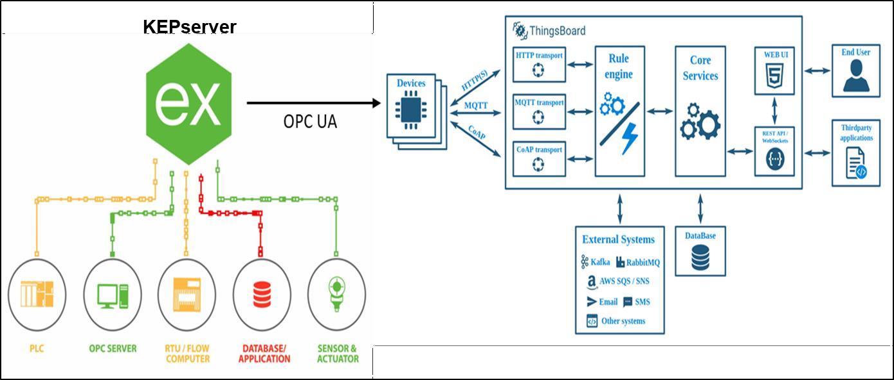

* Analytics and Detection: Platforms like ThingWorx and Jetson Nano processed and analyzed the data.
* Actionable Insights: Dashboards and alerts drove maintenance decisions, safety enforcement, and production planning.
* Long-Term Value:
* Digital culture transformation: Teams began using dashboards as part of their daily routines, reducing information silos.
* Scalability: The modular design of each project supports easy extension to additional machines, PPE types, or production lines.
* Compliance readiness: The company’s safety and operational data became more auditable and reliable, supporting ISO and industry regulations.
* Improved morale and safety engagement: Employees reported higher confidence in management's commitment to safety and operational excellence.

**Figure 2.7.1: Design and Methodology**

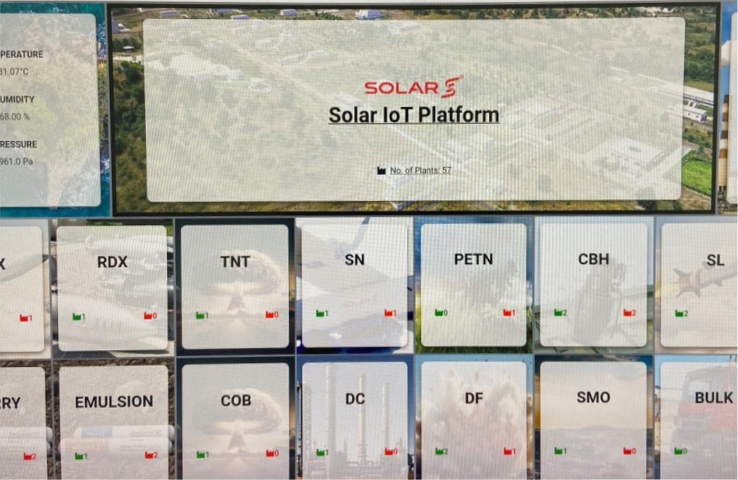

**Figure 2.7.2 : Chakdoh Main Dashboard**

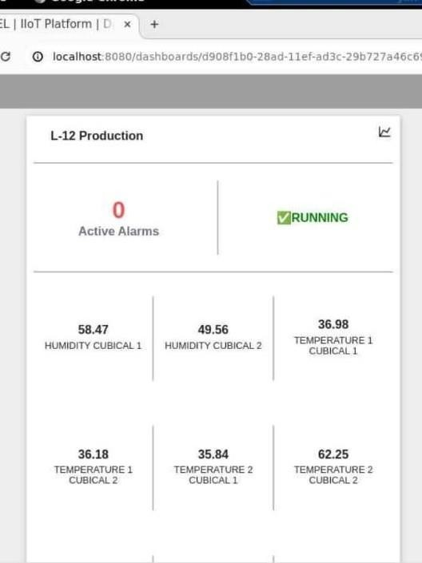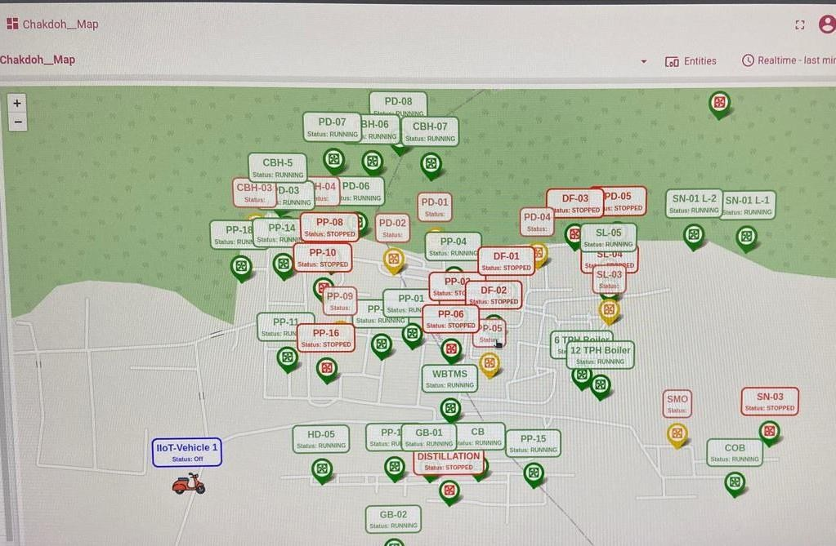

**Figure 2.7.3 : Data Integrated from kepServer Shown**

**Figure 2.7.4 : Maps With Running Status**

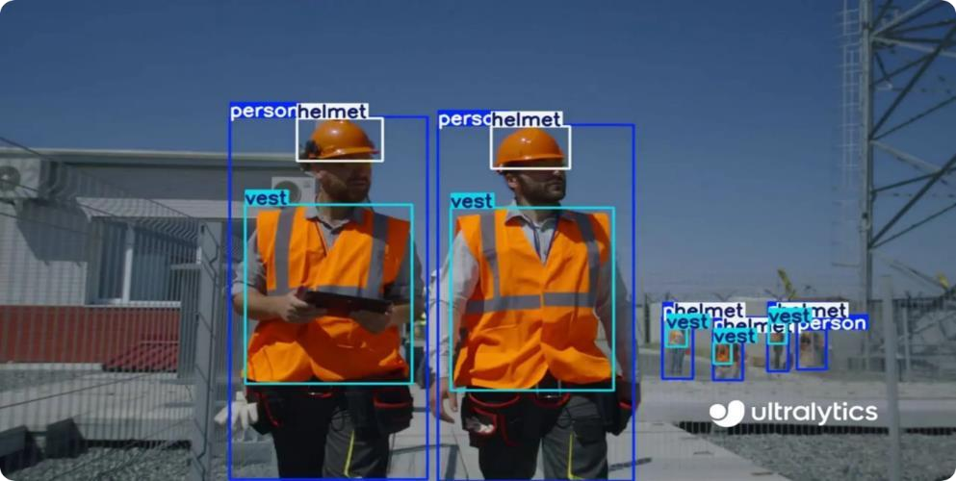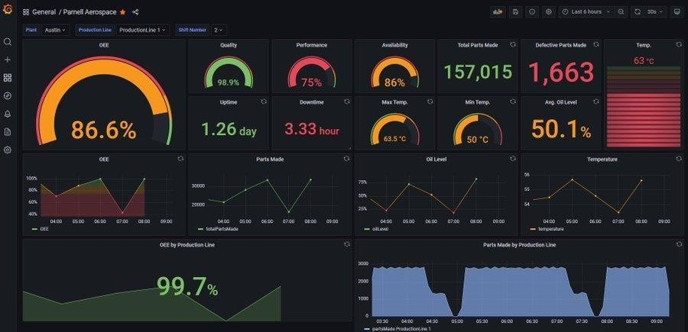

**Figure 2.7.5 : PPEs Module**

**Figure 2.7.6 : OEE on Grafana**

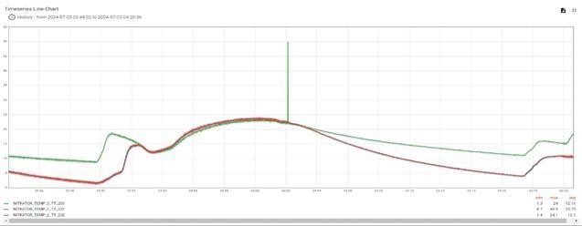

**Figure 2.7.7 :Real Time Data Flow**

**CHAPTER 3**

# REFERENCES

## References

1. Lee, J., Bagheri, B., & Kao, H. A.(2015). A Cyber -Physical Systems architecture for Industry 4.0-based manufacturing systems. Manufacturing Letters, 3, 18–23.
2. Xu, L. D., Xu, E. L., & Li, L. (2018). Industry 4.0: State of the art and future trends. International Journal of Production Research, 56(8), 2941–2962.
3. Gilchrist, A. (2016). Industry 4.0: The Industrial Internet of Things. Apress.
4. Wan, J., etal. (2016). Software-Defined Industrial Internet of Things in the Context of Industry 4.0. IEEE Sensors Journal, 16(20), 7373–7380.
5. Kang, H. S., etal. (2016).Smart manufacturing: Pastresearch, present findings, and future directions. International Journal of Precision Engineering and Manufacturing-Green Technology, 3(1), 111–128.
6. Qin, J., Liu, Y., & Grosvenor, R. (2016). A categorical framework of manufacturing for Industry 4.0 and beyond. Procedia CIRP,52,173–178.
7. IEC White Paper. (2015). Internet of Things: Wireless Sensor Networks. [https://www.iec.ch](https://www.iec.ch/)
8. Cisco.(2015). Fog Computing and the Internet of Things: Extend the Cloud to Where the Things Are. [https://www.cisco.com](https://www.cisco.com/)
9. PTC. (2022). ThingWorx IIoT Platform Documentation. https:/[/www.ptc.com/en/products/iiot/thingworx](http://www.ptc.com/en/products/iiot/thingworx)
10. Yin, S., Ding, S. X., & Xie, X. (2014). Data-driven approaches for industrial process monitoring and fault detection. IEEE Transactions on Industrial Electronics, 61(11), 6418–6428.
11. Jardine, A. K. S., Lin, D., & Banjevic, D. (2006). A review on machinery diagnostics and prognostics implementing condition-based maintenance. Mechanical Systems and Signal Processing, 20(7), 1483– 1510.
12. Rao, B. C. (2017). Maintenance Engineering and Management. Khanna Publishers.
13. IBM. (2023). Predictive Maintenance with IBM Maximo. https:/[/www.ibm.com/products/maximo](http://www.ibm.com/products/maximo)
14. LoRa Alliance. (2022). LoRa WAN Technical Overview.[https://lora-alliance.org](https://lora-alliance.org/)
15. National Instruments. (2021). Condition Monitoring Fundamentals. [https://www.ni.com](https://www.ni.com/)
16. Edge Impulse. (2022). Edge AI for Predictive Maintenance. [https://www.edgeimpulse.com](https://www.edgeimpulse.com/)
17. Jocher, G., etal. (2023). YOLOv5 by Ultralytics. GitHub Repository. <https://github.com/ultralytics/yolov5>
18. Redmon,J.,&Farhadi,A.(2018).YOLOv3:AnIncrementalImprovement. arXiv:1804.02767
19. NVIDIA. (2023). Jetson Nano Developer Kit Documentation. <https://developer.nvidia.com/embedded/jetson-nano>
20. NVIDIA. (2022). Deploying Deep Learning Models on Edge Devices. [https://developer.nvidia.com](https://developer.nvidia.com/)
21. Open CV. (2023). Open CV Documentation. https://docs.opencv.org
22. Chen,H.,&Xue,S.(2021).Helmetdetectionusingdeeplearningforindustrial safety.

IEEE Access, 9, 43238–43249.

1. Zhang, Y., etal. (2020). Real-time personal protective equipment detection for construction sites. Automation in Construction, 110, 103013.
2. Label Img. (2022). Image Annotation Tool. <https://github.com/tzutalin/labelImg>
3. Tensor RT. (2022). High-performance inference optimizer by NVIDIA. <https://developer.nvidia.com/tensorrt>
4. Grafana Labs. (2023).Grafana Documentation. https://grafana.com/docs
5. Influx Data.(2023).Influx DB Documentation. https://docs.influxdata.com
6. Eclipse Foundation.(2023).MQTTProtocolSpecification.[https://mqtt.org](https://mqtt.org/)
7. Telegraf. (2022). Server Agent for Collecting & Reporting Metrics. https:/[/www.influxdata.com/time-series-platform/telegraf/](http://www.influxdata.com/time-series-platform/telegraf/)
8. Reyes, R., & Ramírez, D.(2020). Monitoring industrial equipment using Grafana and InfluxDB. IJACSA, 11(6), 112–118.
9. Dey, A., & Roy, R. (2021). Real-time OEE monitoring framework for smart factories. Procedia CIRP, 96, 234–239.
10. Occupational Safety and Health Administration (OSHA). (2022). PPE Standards

And Guidelines. https://[www.osha.gov/personal-protective-equipment](http://www.osha.gov/personal-protective-equipment)

1. International Labour Organization (ILO). (2021). Occupational Safety and Health Guidelines. [https://www.ilo.org](https://www.ilo.org/)
2. Mohamed, S., & Ali, H. (2016). Human behavior modeling for safety compliance using AI. Automation in Construction, 63, 110–121.
3. ISO45001:2018.Occupational health and safety management systems— Requirements with guidance for use. ISO.
4. Microsoft Azure.(2023). Azure IoT Edge Documentation. <https://learn.microsoft.com/en-us/azure/iot-edge/>
5. AWS.(2022).AWS Greengrass Edge Computing. <https://aws.amazon.com/greengrass/>
6. Apache Kafka.(2023). Kafka for Real-Time Stream Processing. [https://kafka.apache.org](https://kafka.apache.org/)
7. Node-RED.(2022).Low-Code Programming for IoT. [https://nodered.org](https://nodered.org/)

**APPENDICES**

**Appendices**

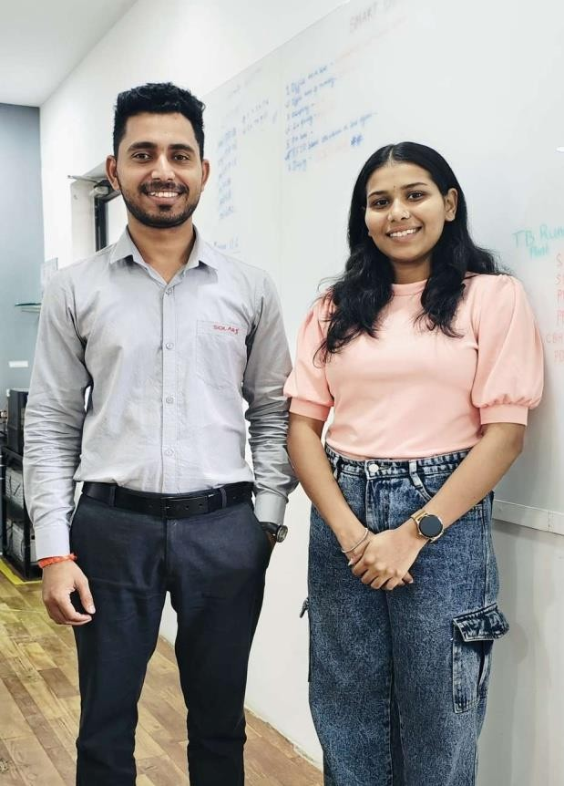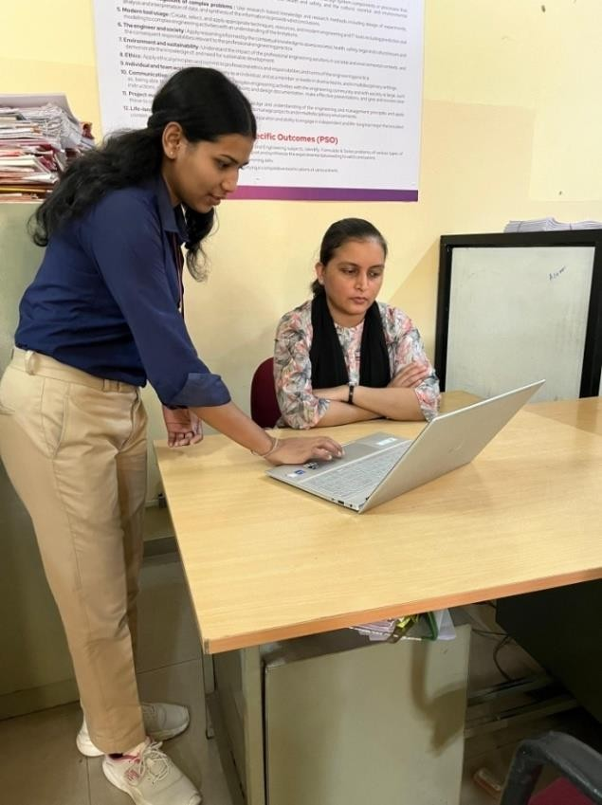

* 1. **Photo with Industry Supervisor**
  2. **Photo With Institute Guide**